Spring Data JPA
Part 1: Spring Data JPA Fundamentals
(Introduction, ORM, JPA, Creating Tables, Inserting Data, findAll(), findById())

Assignment 1: Student Management System
Scenario
A college wants to store and manage student records using Spring Data JPA instead of writing SQL queries manually.
Requirements
- Create a Spring Boot project with Spring Data JPA.
- Configure MySQL database.
- Create a Student entity:
  - studentId
  - studentName
  - course
  - marks
- Create a repository using JpaRepository.
- Insert 5 student records.
- Implement:
  - findAll()
  - findById()
- Display the retrieved data.
Sample Output
----- All Students -----
101 - Arun - Java - 85
102 - Priya - Python - 90
103 - Karthik - Spring Boot - 88
----- Student By ID -----
ID : 101
Name : Arun
Course : Java
Marks : 85

Solution

Structure
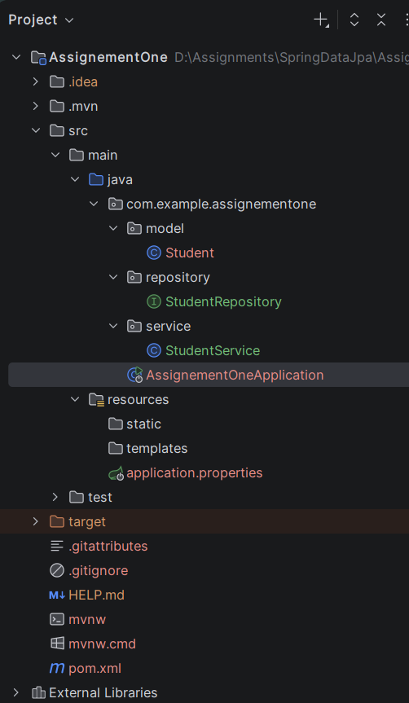

pom.xml
<?xml version="1.0" encoding="UTF-8"?>
<project xmlns="http://maven.apache.org/POM/4.0.0" xmlns:xsi="http://www.w3.org/2001/XMLSchema-instance"
xsi:schemaLocation="http://maven.apache.org/POM/4.0.0 https://maven.apache.org/xsd/maven-4.0.0.xsd">
<modelVersion>4.0.0</modelVersion>
<parent>
<groupId>org.springframework.boot</groupId>
<artifactId>spring-boot-starter-parent</artifactId>
<version>4.1.0</version>
<relativePath/> <!-- lookup parent from repository -->
</parent>
<groupId>com.example</groupId>
<artifactId>AssignementOne</artifactId>
<version>0.0.1-SNAPSHOT</version>
<name>AssignementOne</name>
<description>AssignementOne</description>
<url/>
<licenses>
<license/>
</licenses>
<developers>
<developer/>
</developers>
<scm>
<connection/>
<developerConnection/>
<tag/>
<url/>
</scm>
<properties>
<java.version>21</java.version>
</properties>
<dependencies>
<dependency>
<groupId>org.springframework.boot</groupId>
<artifactId>spring-boot-starter-data-jpa</artifactId>
</dependency>
<dependency>
<groupId>org.springframework.boot</groupId>
<artifactId>spring-boot-starter-webmvc</artifactId>
</dependency>
<dependency>
<groupId>com.mysql</groupId>
<artifactId>mysql-connector-j</artifactId>
<scope>runtime</scope>
</dependency>
</dependencies>
<build>
<plugins>
<plugin>
<groupId>org.springframework.boot</groupId>
<artifactId>spring-boot-maven-plugin</artifactId>
</plugin>
</plugins>
</build>
</project>

application.properties
spring.application.name=AssignementOne
spring.datasource.url=jdbc:mysql://localhost:3306/college_db
spring.datasource.username=root
spring.datasource.password=root@123
spring.datasource.driver-class-name=com.mysql.cj.jdbc.Driver
spring.jpa.hibernate.ddl-auto=update
spring.jpa.show-sql=true
spring.jpa.properties.hibernate.format_sql=true

model/Student.java
package com.example.assignementone.model;
import jakarta.persistence.Entity;
import jakarta.persistence.Id;
import jakarta.persistence.Table;
@Entity
@Table(name = "studentjpa")
public class Student {
@Id
private int studentId;
private String studentName;
private String course;
private int marks;
public Student() {}
public Student(int studentId, String studentName, String course, int marks) {
this.studentId = studentId;
this.studentName = studentName;
this.course = course;
this.marks = marks;
}
public int getStudentId() { return studentId; }
public void setStudentId(int studentId) { this.studentId = studentId; }
public String getStudentName() { return studentName; }
public void setStudentName(String studentName) { this.studentName = studentName; }
public String getCourse() { return course; }
public void setCourse(String course) { this.course = course; }
public int getMarks() { return marks; }
public void setMarks(int marks) { this.marks = marks; }
}

service/StudentService.java
package com.example.assignementone.service;
import com.example.assignementone.model.Student;
import com.example.assignementone.repository.StudentRepository;
import org.springframework.stereotype.Service;
import java.util.List;
import java.util.Optional;
@Service
public class StudentService {
private final StudentRepository studentRepository;
public StudentService(StudentRepository studentRepository) {
this.studentRepository = studentRepository;
}
public void saveAllStudents(List<Student> students) {
studentRepository.saveAll(students);
}
public List<Student> getAllStudents() {
return studentRepository.findAll();
}
public Optional<Student> getStudentById(int id) {
return studentRepository.findById(id);
}
}

repository/StudentRepository.java
package com.example.assignementone.repository;
import com.example.assignementone.model.Student;
import org.springframework.data.jpa.repository.JpaRepository;
import org.springframework.stereotype.Repository;
@Repository
public interface StudentRepository extends JpaRepository<Student, Integer> {
}

AssignmentOneApplication.java
package com.example.assignementone;
import com.example.assignementone.model.Student;
import com.example.assignementone.service.StudentService;
import org.springframework.boot.CommandLineRunner;
import org.springframework.boot.SpringApplication;
import org.springframework.boot.autoconfigure.SpringBootApplication;
import org.springframework.context.annotation.Bean;
import java.util.Arrays;
import java.util.List;
import java.util.Optional;
@SpringBootApplication
public class AssignementOneApplication {
public static void main(String[] args) {
SpringApplication.run(AssignementOneApplication.class, args);
}
@Bean
public CommandLineRunner run(StudentService studentService) {
return args -> {
List<Student> initialStudents = Arrays.asList(
new Student(101, "Arun", "Java", 85),
new Student(102, "Priya", "Python", 90),
new Student(103, "Karthik", "Spring Boot", 88),
new Student(104, "Suresh", "React", 80),
new Student(105, "Anitha", "Data Science", 92)
);
studentService.saveAllStudents(initialStudents);
System.out.println("\n----- All Students -----");
List<Student> students = studentService.getAllStudents();
for (Student s : students) {
System.out.println(s.getStudentId() + " - " + s.getStudentName() + " - " + s.getCourse() + " - " + s.getMarks());
}
System.out.println("\n----- Student By ID -----");
Optional<Student> optionalStudent = studentService.getStudentById(101);
if (optionalStudent.isPresent()) {
Student student = optionalStudent.get();
System.out.println("ID : " + student.getStudentId());
System.out.println("Name : " + student.getStudentName());
System.out.println("Course : " + student.getCourse());
System.out.println("Marks : " + student.getMarks());
} else {
System.out.println("Student not found!");
}
};
}
}

Output:
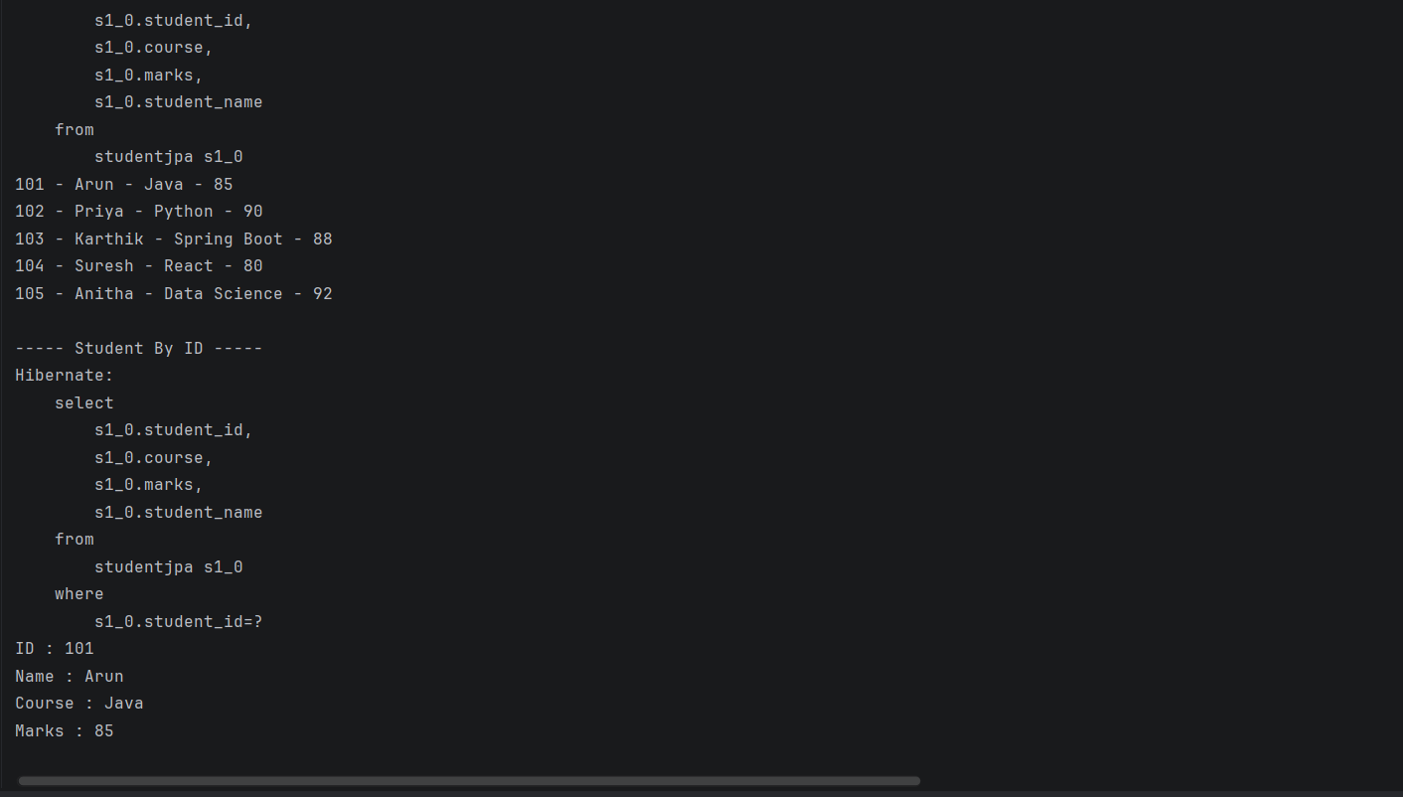

Assignment 2: Employee Directory
Scenario
An IT company wants to maintain employee information using JPA.
Requirements
- Create an Employee Entity:
  - empId
  - empName
  - department
  - salary
- Auto-generate the database table.
- Insert employee records.
- Retrieve:
  - All employees
  - Employee by ID
Sample Output
Employee Details
101 - John - IT - 50000
102 - David - HR - 45000
103 - Rahul - Finance – 60000
Solution:
Structure
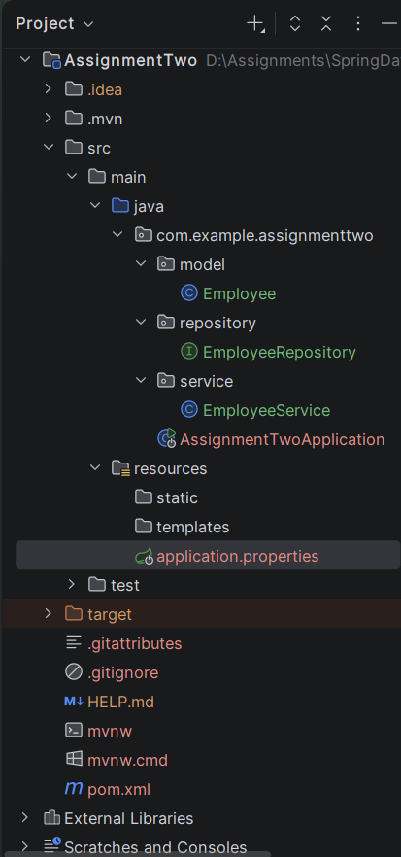
pom.xml
<?xml version="1.0" encoding="UTF-8"?>
<project xmlns="http://maven.apache.org/POM/4.0.0" xmlns:xsi="http://www.w3.org/2001/XMLSchema-instance"
xsi:schemaLocation="http://maven.apache.org/POM/4.0.0 https://maven.apache.org/xsd/maven-4.0.0.xsd">
<modelVersion>4.0.0</modelVersion>
<parent>
<groupId>org.springframework.boot</groupId>
<artifactId>spring-boot-starter-parent</artifactId>
<version>4.1.0</version>
<relativePath/> <!-- lookup parent from repository -->
</parent>
<groupId>com.example</groupId>
<artifactId>AssignmentTwo</artifactId>
<version>0.0.1-SNAPSHOT</version>
<name>AssignmentTwo</name>
<description>AssignmentTwo</description>
<url/>
<licenses>
<license/>
</licenses>
<developers>
<developer/>
</developers>
<scm>
<connection/>
<developerConnection/>
<tag/>
<url/>
</scm>
<properties>
<java.version>21</java.version>
</properties>
<dependencies>
<dependency>
<groupId>org.springframework.boot</groupId>
<artifactId>spring-boot-starter-data-jpa</artifactId>
</dependency>
<dependency>
<groupId>org.springframework.boot</groupId>
<artifactId>spring-boot-starter-webmvc</artifactId>
</dependency>
<dependency>
<groupId>com.mysql</groupId>
<artifactId>mysql-connector-j</artifactId>
<scope>runtime</scope>
</dependency>
</dependencies>
<build>
<plugins>
<plugin>
<groupId>org.springframework.boot</groupId>
<artifactId>spring-boot-maven-plugin</artifactId>
</plugin>
</plugins>
</build>
</project>

resources/application.properties
spring.application.name=AssignmentTwo
spring.datasource.url=jdbc:mysql://localhost:3306/employee
spring.datasource.username=root
spring.datasource.password=root@123
spring.datasource.driver-class-name=com.mysql.cj.jdbc.Driver
spring.jpa.hibernate.ddl-auto=update
spring.jpa.show-sql=true
spring.jpa.properties.hibernate.format_sql=true

model/Employee.java
package com.example.assignmenttwo.model;
import jakarta.persistence.Entity;
import jakarta.persistence.GeneratedValue;
import jakarta.persistence.GenerationType;
import jakarta.persistence.Id;
import jakarta.persistence.Table;
@Entity
@Table(name = "employeesjpa")
public class Employee {
@Id
@GeneratedValue(strategy = GenerationType.IDENTITY)
private Long empId;
private String empName;
private String department;
private double salary;
public Employee() {}
public Employee(String empName, String department, double salary) {
this.empName = empName;
this.department = department;
this.salary = salary;
}
public Long getEmpId() { return empId; }
public void setEmpId(Long empId) { this.empId = empId; }
public String getEmpName() { return empName; }
public void setEmpName(String empName) { this.empName = empName; }
public String getDepartment() { return department; }
public void setDepartment(String department) { this.department = department; }
public double getSalary() { return salary; }
public void setSalary(double salary) { this.salary = salary; }
}

service/EmployeeService.java
package com.example.assignmenttwo.service;
import com.example.assignmenttwo.model.Employee;
import com.example.assignmenttwo.repository.EmployeeRepository;
import org.springframework.stereotype.Service;
import java.util.List;
import java.util.Optional;
@Service
public class EmployeeService {
private final EmployeeRepository employeeRepository;
public EmployeeService(EmployeeRepository employeeRepository) {
this.employeeRepository = employeeRepository;
}
public void saveAllEmployees(List<Employee> employees) {
employeeRepository.saveAll(employees);
}
public List<Employee> getAllEmployees() {
return employeeRepository.findAll();
}
public Optional<Employee> getEmployeeById(Long id) {
return employeeRepository.findById(id);
}
}

repository/EmployeeRepository.java
package com.example.assignmenttwo.repository;
import com.example.assignmenttwo.model.Employee;
import org.springframework.data.jpa.repository.JpaRepository;
import org.springframework.stereotype.Repository;
@Repository
public interface EmployeeRepository extends JpaRepository<Employee, Long> {
}

AssignmentTwoApplication.java
package com.example.assignmenttwo;
import com.example.assignmenttwo.model.Employee;
import com.example.assignmenttwo.service.EmployeeService;
import org.springframework.boot.CommandLineRunner;
import org.springframework.boot.SpringApplication;
import org.springframework.boot.autoconfigure.SpringBootApplication;
import org.springframework.context.annotation.Bean;
import java.util.Arrays;
import java.util.List;
import java.util.Optional;
@SpringBootApplication
public class AssignmentTwoApplication {
public static void main(String[] args) {
SpringApplication.run(AssignmentTwoApplication.class, args);
}
@Bean
public CommandLineRunner run(EmployeeService employeeService) {
return args -> {
List<Employee> initialEmployees = Arrays.asList(
new Employee("John", "IT", 50000),
new Employee("David", "HR", 45000),
new Employee("Rahul", "Finance", 60000)
);
employeeService.saveAllEmployees(initialEmployees);
System.out.println("\nEmployee Details");
List<Employee> employees = employeeService.getAllEmployees();
for (Employee e : employees) {
System.out.println(e.getEmpId() + " - " + e.getEmpName() + " - " + e.getDepartment() + " - " + (int)e.getSalary());
}
System.out.println("\n----- Employee By ID -----");
Optional<Employee> optionalEmployee = employeeService.getEmployeeById(1L);
if (optionalEmployee.isPresent()) {
Employee e = optionalEmployee.get();
System.out.println("ID : " + e.getEmpId());
System.out.println("Name : " + e.getEmpName());
System.out.println("Department : " + e.getDepartment());
System.out.println("Salary : " + (int)e.getSalary());
} else {
System.out.println("Employee not found!");
}
};
}
}

Output:
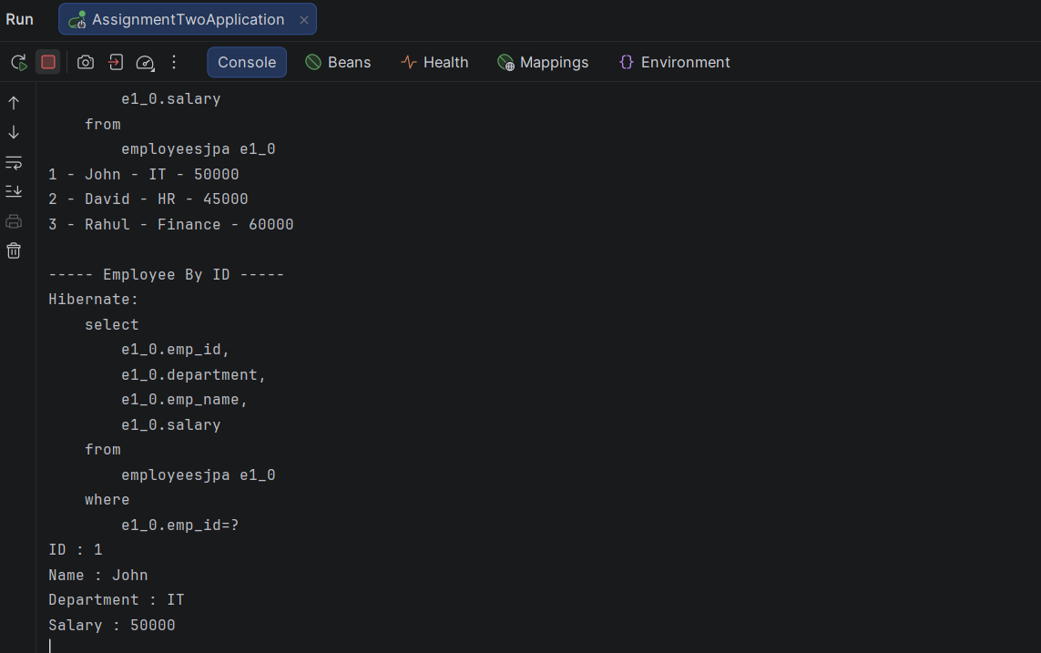

Assignment 3: Job Portal Using JPQL
Create a Job Portal Application.
Entity:
- Job
  - id
  - title
  - company
  - salary
  - location
Implement JPQL Queries:
- Find jobs with salary greater than ₹50,000.
- Find jobs by location.
- Update salary using JPQL.
- Delete jobs by company name.
Expected:
Use @Query and @Modifying.

Solution:
Structure
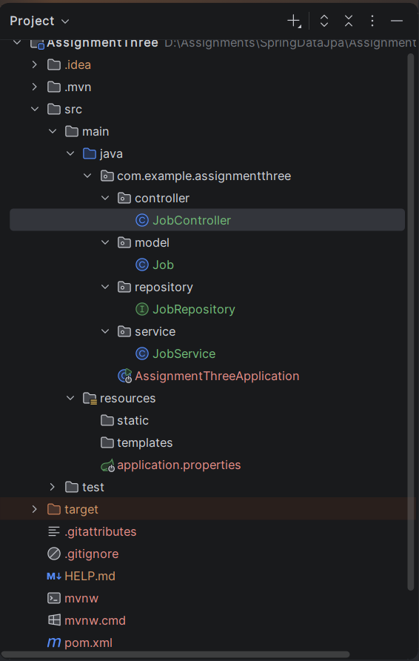
pom.xml
<?xml version="1.0" encoding="UTF-8"?>
<project xmlns="http://maven.apache.org/POM/4.0.0" xmlns:xsi="http://www.w3.org/2001/XMLSchema-instance"
xsi:schemaLocation="http://maven.apache.org/POM/4.0.0 https://maven.apache.org/xsd/maven-4.0.0.xsd">
<modelVersion>4.0.0</modelVersion>
<parent>
<groupId>org.springframework.boot</groupId>
<artifactId>spring-boot-starter-parent</artifactId>
<version>4.1.0</version>
<relativePath/> <!-- lookup parent from repository -->
</parent>
<groupId>com.example</groupId>
<artifactId>AssignmentThree</artifactId>
<version>0.0.1-SNAPSHOT</version>
<name>AssignmentThree</name>
<description>AssignmentThree</description>
<url/>
<licenses>
<license/>
</licenses>
<developers>
<developer/>
</developers>
<scm>
<connection/>
<developerConnection/>
<tag/>
<url/>
</scm>
<properties>
<java.version>21</java.version>
</properties>
<dependencies>
<dependency>
<groupId>org.springframework.boot</groupId>
<artifactId>spring-boot-starter-data-jpa</artifactId>
</dependency>
<dependency>
<groupId>org.springframework.boot</groupId>
<artifactId>spring-boot-starter-webmvc</artifactId>
</dependency>
<dependency>
<groupId>com.mysql</groupId>
<artifactId>mysql-connector-j</artifactId>
<scope>runtime</scope>
</dependency>
</dependencies>
<build>
<plugins>
<plugin>
<groupId>org.springframework.boot</groupId>
<artifactId>spring-boot-maven-plugin</artifactId>
</plugin>
</plugins>
</build>
</project>

resources/application.properties
spring.application.name=AssignmentThree
spring.datasource.url=jdbc:mysql://localhost:3306/employee
spring.datasource.username=root
spring.datasource.password=root@123
spring.datasource.driver-class-name=com.mysql.cj.jdbc.Driver
spring.jpa.hibernate.ddl-auto=update
spring.jpa.show-sql=true
spring.jpa.properties.hibernate.format-sql=true

model/Jobs.java
package com.example.assignmentthree.model;
import jakarta.persistence.Entity;
import jakarta.persistence.GeneratedValue;
import jakarta.persistence.GenerationType;
import jakarta.persistence.Id;
import jakarta.persistence.Table;
@Entity
@Table(name = "jobs")
public class Job {
@Id
@GeneratedValue(strategy = GenerationType.IDENTITY)
private Long id;
private String title;
private String company;
private double salary;
private String location;
public Job() {}
public Job(String title, String company, double salary, String location) {
this.title = title;
this.company = company;
this.salary = salary;
this.location = location;
}
public Long getId() { return id; }
public void setId(Long id) { this.id = id; }
public String getTitle() { return title; }
public void setTitle(String title) { this.title = title; }
public String getCompany() { return company; }
public void setCompany(String company) { this.company = company; }
public double getSalary() { return salary; }
public void setSalary(double salary) { this.salary = salary; }
public String getLocation() { return location; }
public void setLocation(String location) { this.location = location; }
}

controller/JobController.java
package com.example.assignmentthree.controller;
import com.example.assignmentthree.model.Job;
import com.example.assignmentthree.service.JobService;
import org.springframework.http.ResponseEntity;
import org.springframework.web.bind.annotation.DeleteMapping;
import org.springframework.web.bind.annotation.GetMapping;
import org.springframework.web.bind.annotation.PathVariable;
import org.springframework.web.bind.annotation.PostMapping;
import org.springframework.web.bind.annotation.PutMapping;
import org.springframework.web.bind.annotation.RequestBody;
import org.springframework.web.bind.annotation.RequestMapping;
import org.springframework.web.bind.annotation.RequestParam;
import org.springframework.web.bind.annotation.RestController;
import java.util.List;
@RestController
@RequestMapping("/jobs")
public class JobController {
private final JobService jobService;
public JobController(JobService jobService) {
this.jobService = jobService;
}
@PostMapping
public ResponseEntity<Job> createJob(@RequestBody Job job) {
return ResponseEntity.ok(jobService.saveJob(job));
}
@GetMapping
public ResponseEntity<List<Job>> getAllJobs() {
return ResponseEntity.ok(jobService.getAllJobs());
}
@GetMapping("/high-salary")
public ResponseEntity<List<Job>> getJobsWithHighSalary(@RequestParam(defaultValue = "50000") double minSalary) {
return ResponseEntity.ok(jobService.getHighSalaryJobs(minSalary));
}
@GetMapping("/location/{location}")
public ResponseEntity<List<Job>> getJobsByLocation(@PathVariable String location) {
return ResponseEntity.ok(jobService.getJobsByLocation(location));
}
@PutMapping("/{id}/salary")
public ResponseEntity<String> updateSalary(@PathVariable Long id, @RequestParam double salary) {
int updatedRows = jobService.updateSalary(id, salary);
if (updatedRows > 0) {
return ResponseEntity.ok("Job salary updated successfully.");
}
return ResponseEntity.badRequest().body("Job ID not found.");
}
@DeleteMapping("/company/{company}")
public ResponseEntity<String> deleteByCompany(@PathVariable String company) {
int deletedRows = jobService.deleteByCompany(company);
return ResponseEntity.ok("Deleted " + deletedRows + " job(s) from " + company);
}
}

service/JobService.java
package com.example.assignmentthree.service;
import com.example.assignmentthree.model.Job;
import com.example.assignmentthree.repository.JobRepository;
import org.springframework.stereotype.Service;
import java.util.List;
@Service
public class JobService {
private final JobRepository jobRepository;
public JobService(JobRepository jobRepository) {
this.jobRepository = jobRepository;
}
public Job saveJob(Job job) {
return jobRepository.save(job);
}
public List<Job> getHighSalaryJobs(double minSalary) {
return jobRepository.findJobsBySalaryGreaterThan(minSalary);
}
public List<Job> getJobsByLocation(String location) {
return jobRepository.findJobsByLocation(location);
}
public int updateSalary(Long id, double salary) {
return jobRepository.updateJobSalary(id, salary);
}
public int deleteByCompany(String company) {
return jobRepository.deleteJobsByCompany(company);
}
public List<Job> getAllJobs() {
return jobRepository.findAll();
}
}
repository/JobRepository.java
package com.example.assignmentthree.repository;
import com.example.assignmentthree.model.Job;
import org.springframework.data.jpa.repository.JpaRepository;
import org.springframework.data.jpa.repository.Modifying;
import org.springframework.data.jpa.repository.Query;
import org.springframework.data.repository.query.Param;
import org.springframework.stereotype.Repository;
import org.springframework.transaction.annotation.Transactional;
import java.util.List;
@Repository
public interface JobRepository extends JpaRepository<Job, Long> {
@Query("SELECT j FROM Job j WHERE j.salary > :salary")
List<Job> findJobsBySalaryGreaterThan(@Param("salary") double salary);
@Query("SELECT j FROM Job j WHERE j.location = :location")
List<Job> findJobsByLocation(@Param("location") String location);
@Modifying
@Transactional
@Query("UPDATE Job j SET j.salary = :salary WHERE j.id = :id")
int updateJobSalary(@Param("id") Long id, @Param("salary") double salary);
@Modifying
@Transactional
@Query("DELETE FROM Job j WHERE j.company = :company")
int deleteJobsByCompany(@Param("company") String company);
}

AssignmentThreeApplication.java
package com.example.assignmentthree;
import org.springframework.boot.SpringApplication;
import org.springframework.boot.autoconfigure.SpringBootApplication;
@SpringBootApplication
public class AssignmentThreeApplication {
public static void main(String[] args) {
SpringApplication.run(AssignmentThreeApplication.class, args);
}
}

Output:
